**CH3 Information Systems, Organizations, and Strategy**

學習目標:

* 1. 管理人員需要了解哪些組織的特點才能成功構建和使用資訊系

統？

* 1. 資訊訊系統對組織有何影響？
  2. 波特的競爭力模型(Porter’s competitive forces model)，價值鏈模型(value chain model)，協同作用(synergies)，核心競爭力(core competencies)和網路經濟學(network economics)如何幫助公司使用資訊系統制定競爭策略？
  3. 策略資訊系統(strategic information systems)面臨哪些挑戰，應如

何應對？

* Tate & Lyle Devise a Global IT Strategy
* How will the Account Reconciliation and Task Management system help Tate & Lyle remain competitive? Why did managers choose a single, global system? What specific problems did this system solve?

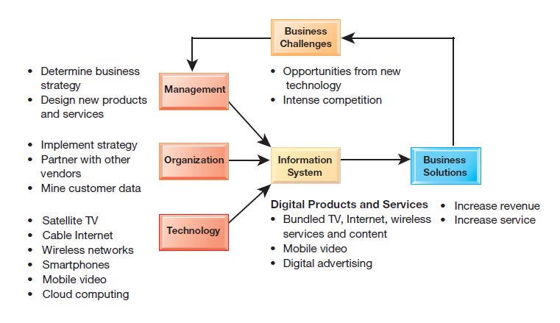

1. Which features of organizations do managers need to know about to build and use information systems successfully?
   * Preface

* Information technology and organizations influence each other
* Relationship influenced by organization’s
  + - * Structure
      * Business processes
      * Politics
      * Culture
      * Environment
      * Management decisions

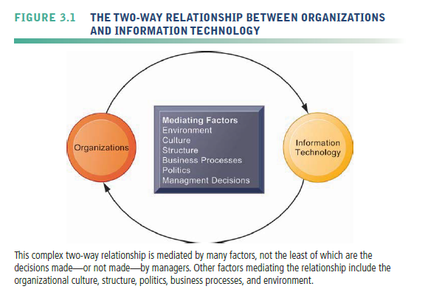

* need to understand how information systems can change social and work life in your firm
* You will not be able to design new systems successfully or understand existing systems without understanding your own business organization.
  + What Is an Organization?
* Organization
  + a stable, formal social structure that takes resources from the environment and processes them to produce outputs
  + Technical definition
    - Capital and labor are primary production factors provided by the environment.
    - The organization (the firm) transforms these inputs into products and services in a production function.
    - The products and services are consumed by environments in return for supply inputs

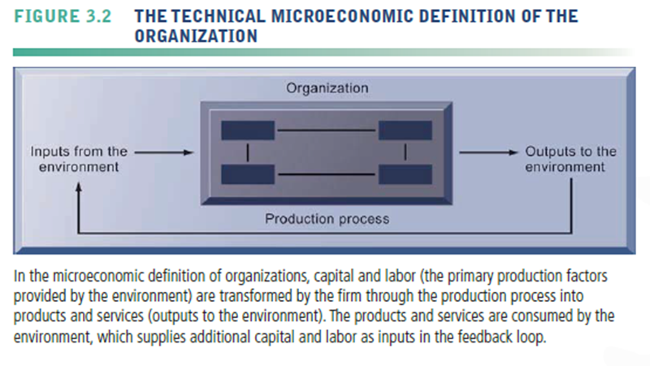

* + - A formal legal entity with internal rules and procedures, as well as a social structure
    - powerful and simple, but it is not very descriptive or even predictive of real-world organizations.
  + Behavioral definition
    - A collection of rights, privileges, obligations, and responsibilities that is delicately balanced over a period of time through conflict and conflict resolution
    - people who work in organizations develop customary ways of working
    - gain attachments to existing relationships
    - make arrangements with subordinates and superiors about how work will be done
    - Most of these arrangements and feelings are not discussed in any formal rulebook.

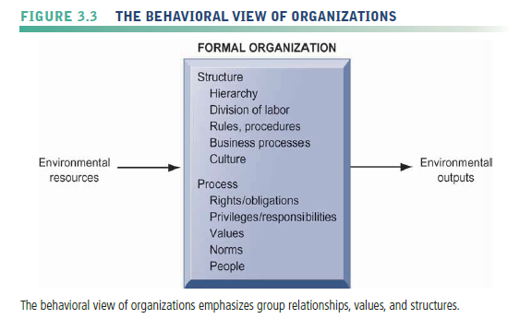

* How do these definitions of organizations related to information systems technology?
* A technical view of organizations encourages us to focus on how inputs are combined to create outputs when technology changes are introduced into the company.
  + - infinitely malleable, with capital and labor substituting for each other quite easily
* the more realistic behavioral definition of an organization
  + - some information systems change the organizational balance of rights, privileges, obligations, responsibilities, and feelings.
    - take a long time, be very disruptive, and requires more resources to support training and learning
* The technical and behavioral definitions of organizations are not contradictory.
  + - * The technical definition tells us how thousands of firms in competitive markets combine capital, labor, and information technology
      * the behavioral model takes us inside the individual firm to see how that technology affects the organization’s inner workings.
  + Features of Organizations
* Routines and Business Processes
* Routines—tandard operating procedures
  + - precise rules, procedures, and practices that have been developed to cope with virtually all expected situations.
    - employees learn these routines, they become highly productive and efficient, and the firm is able to reduce its costs over time as efficiency increases.
* Business processes—collections of routines
  + - A business firm, in turn, is a collection of business processes

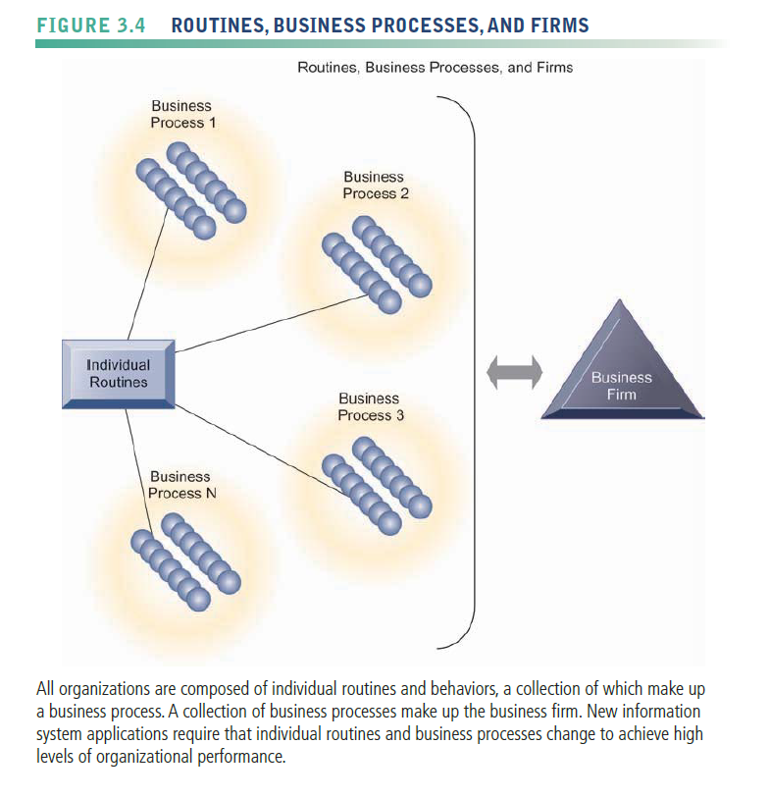

* Organizational Politics
* divergent viewpoints about how resources, rewards, and punishments should be distributed.
  + - both managers and employees result in political struggle for resources, competition, and conflict within every organization.
* Political resistance is one of the great difficulties of bringing about organizational change—especially the development of new information systems
* all large information systems investments by a firm that bring about significant changes in strategy, business objectives, business processes, and procedures become politically charged events.
* Organizational Culture
* encompasses this set of assumptions about
  + - what products the organization should produce
    - How and where it should be produced
    - For whom the products should be produced
* Business processes
  + - the actual way business firms produce value—are usually ensconced in the organization’s culture.
* a powerful unifying force that restrains political conflict and promotes common understanding, agreement on procedures, and common practices.
* a powerful restraint on change, especially technological change.
* Any technological change that threatens commonly held cultural assumptions usually meets a great deal of resistance
  + - the only sensible way for a firm to move forward is to employ a new technology that directly opposes an existing organizational culture
* Organizational Environments
* Organizations reside in environments from which they draw resources and to which they supply goods and services
* Organizations and environments have a reciprocal relationship(互惠關係)
* organizations are open to, and dependent on, the social and physical environment that surrounds them
* Organizations must respond to legislative and other requirements imposed by government, as well as the actions of customers and competitors.
* organizations can influence their environments.

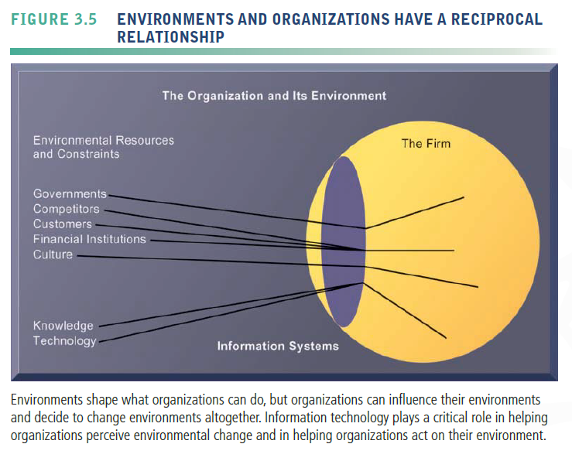

* Environments generally change much faster than organizations.
* **Disruptive Technologies**
  + - Technology that brings about sweeping change to businesses, industries, markets
* What makes a technology disruptive?
  + - In some cases, disruptive technologies are substitute products that perform as well as or better (often much better) than anything currently produced, entire industries were put out of business
    - In other cases, disruptive technologies simply extend the market, usually with less functionality and much less cost, than existing products.
* Some firms are able to create these technologies and ride the wave to profits; others learn quickly and adapt their business; still others are obliterated because their products, services, and business models become obsolete.
* First movers and fast followers
  + - First movers—inventors of disruptive technologies
    - Fast followers—firms with the size and resources to capitalize on that technology

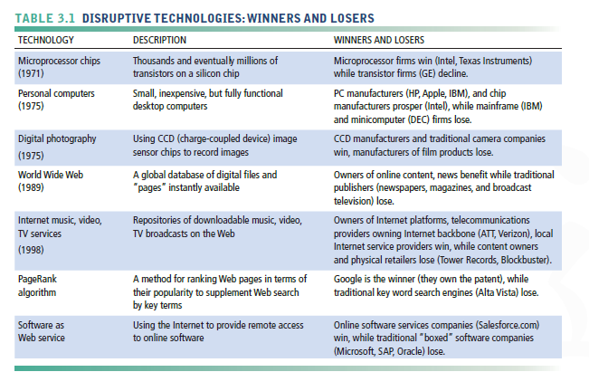

* Organizational Structure
* All organizations have a structure or shape
* Mintzberg’s classification, identifies five basic kinds of organizational structure.

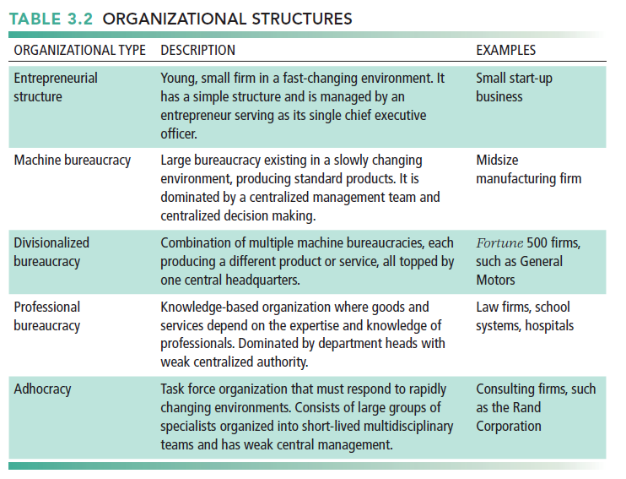

* The kind of information systems you find in a business firm—and the nature of problems with these systems—often reflects the type of organizational structure
* Other Organizational Features
* Organizations have goals and use different means to achieve them.
  + - Coercive, utilitarian, normative, and so on
* Constituencies - Organizations also serve different groups or have different constituencies, some primarily benefiting their members, others benefiting clients, stockholders, or the public
* Another way organizations differ is by the tasks they perform and the technology they use
* Tasks - Some organizations perform primarily routine tasks that can be reduced to formal rules that require little judgment, whereas others work primarily with nonroutine tasks.
* Leadership styles - The nature of leadership differs greatly from one organization to another

1. HOW INFORMATION SYSTEMS IMPACT ORGANIZATIONS AND BUSINESS FIRMS
   * Economic Impacts

* IT changes both the relative costs of capital and the costs of information
* Information systems technology can be viewed as a factor of production that can be substituted for traditional capital and labor.
* a decline in the number of middle managers and clerical workers as information technology substitutes for their labor.
* also substitutes for other forms of capital such as buildings and machinery, which remain relatively expensive
* IT affects the cost and quality of information and changes economics of information.
* helps firms contract in size because it can reduce transaction costs—the costs incurred when a firm buys on the marketplace what it cannot make itself
  + - Outsourcing
* Transaction cost theory
* Information technology, especially the use of networks, can help firms lower the cost of market participation (transaction costs)
  + - Vertical integration, hiring more employees, buying suppliers and distributors
    - making it worthwhile for firms to contract with external suppliers instead of using internal sources.
    - shrink in size (numbers of employees), far less expensive to outsource work to a competitive marketplace rather than hire employees.
    - contract for the purchase of goods and services in the marketplace rather than to make the product or offer the service itself.
    - Firm size can stay constant or contract even as the company increases its revenues
* agency theory - reduce internal management costs.
* Firm is nexus of contracts among self-interested parties requiring supervision.
* Firms experience agency costs (the cost of managing and supervising) which rise as firm grows.
* By reducing the costs of acquiring and analyzing information, reduce agency costs
  + - because it becomes easier for managers to oversee a greater number of employees.
* By reducing overall management costs, increase revenues while shrinking the number of middle managers and clerical workers.
  + Organizational and Behavioral Impacts
* IT Flattens Organizations
* IT facilitates flattening of hierarchies
  + - broadening the distribution of information to empower lower-level employees and increase management efficiency
* IT pushes decision-making rights lower in the organization
  + - lower-level employees receive the information they need to make decisions without supervision
* managers now receive so much more accurate information on time, they become much faster at making decisions
  + - Fewer managers are required.
    - Management costs decline as a percentage of revenue
    - hierarchy becomes much more efficient.
* management span of control has also been broadened
  + - high level managers to manage and control more workers spread over greater distances
    - eliminated thousands of middle manager

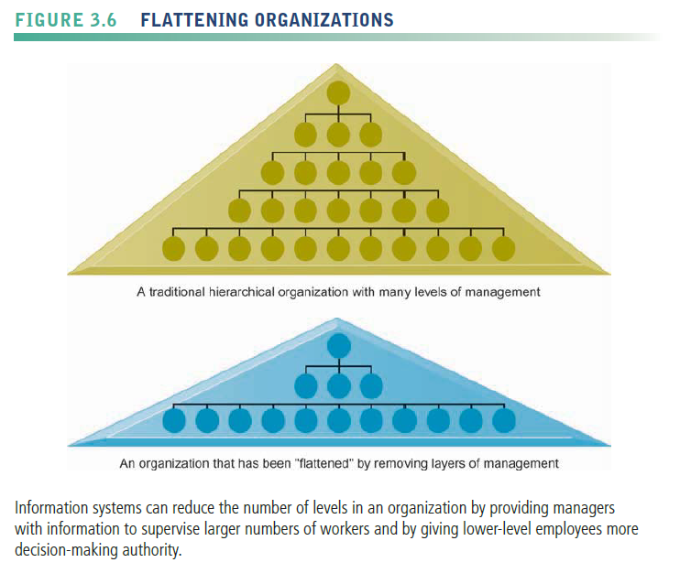

* Postindustrial Organizations
* authority increasingly relies on knowledge and competence
  + - the shape of organizations flattens because professional workers tend to be self managing
    - decision making should become more decentralized as knowledge and information become more widespread throughout the firm
* encourage task force-networked organizations in which groups of professionals come together—face to face or electronically— for short periods of time to accomplish a specific task. once the task is accomplished, the individuals join other task forces.
* Understanding Organizational Resistance to Change
* Information systems become bound up in organizational politics
  + - influence access to a key resource—namely, information.
* Many new information systems require changes in personal
  + - be painful for those involved
    - require retraining and additional effort that may or may not be compensated
* potentially change an organization’s structure, culture, business processes, and strategy
  + - often considerable resistance to them when they are introduced.
* Research on organizational resistance to innovation suggests that four factors are paramount
  + 1. the nature of the IT innovation
    2. the organization’s structure
    3. the culture of people in the organization
    4. the tasks impacted by the innovation
    - bring about change is to change the technology, tasks, structure, and people simultaneously.

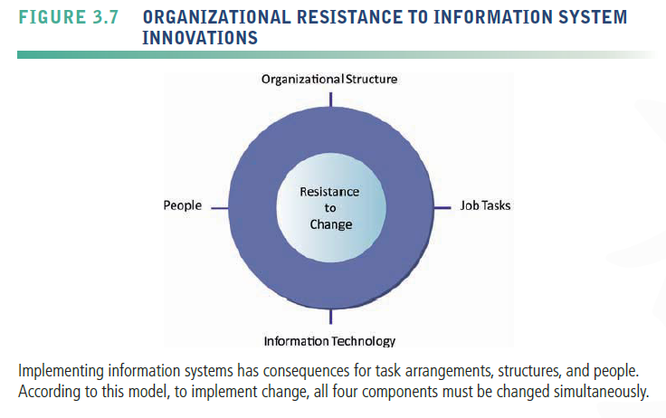

* organizational resistance to change is so powerful, many information technology investments flounder and do not increase productivity.
  + - the most common reason for failure of large projects to reach their objectives is not the failure of the technology, but organizational and political resistance to change.
  + The Internet and Organizations
* increases the accessibility, storage, and distribution of information and knowledge for organizations
* dramatically lowering the transaction and agency costs facing most organizations
* Example: Large firm delivers internal manuals to employees via a corporate Web site, saving millions of dollars in distribution costs
* Businesses are rapidly rebuilding some of their key business processes based on Internet technology and making this technology a key component of their IT infrastructures
  + Implications for the Design and Understanding of Information Systems
* the central organizational factors to consider when planning a new system are the following :
* Environment
* Structure
  + - * Hierarchy, specialization, routines, business processes
* Culture and politics
* Type of organization and style of leadership
* Main interest groups affected by system; attitudes of end users
* Tasks, decisions, and business processes the system will assist

1. How do Porter’s competitive forces model, the value chain model, synergies, core competencies, and network economics help companies develop competitive strategies using information systems?
   * Preface

* why do some firms do better than others, and how do they achieve competitive advantage?
* How can you analyze a business and identify its strategic advantages?
* How can you develop a strategic advantage for your own business?
* how do information systems contribute to strategic advantages?
  + Porter’s Competitive Forces Model
* provides a general view of the firm, its competitors, and the firm’s environment.
* Five competitive forces shape fate of firm

1. Traditional competitors
2. New market entrants
3. Substitute products and services
4. Customers
5. Suppliers

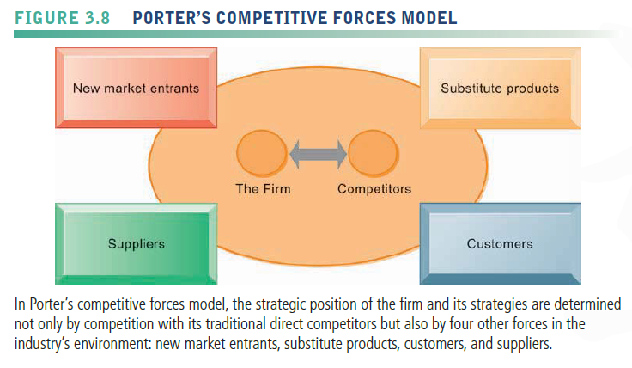

* Traditional Competitors
* All firms share market space with competitors who are continuously devising new products, services, efficiencies, and switching costs.
* New Market Entrants
* Some industries, there are very low barriers to entry, whereas in other industries, entry is very difficult.
* New companies have several possible advantages
  + - not locked into old plants and equipment
    - hire younger workers who are less expensive and perhaps more innovative
    - not encumbered by old worn-out brand names
    - more highly motivated than traditional occupants of an industry.
* These advantages are also their weakness
* depend on outside financing for new plants and equipment, which can be expensive
* less-experienced workforce
* little brand recognition.
* Substitute Products and Services
* Substitutes customers might use if your prices become too high
* New technologies create new substitutes all the time
* The more substitute products and services in your industry, the less you can control pricing and the lower your profit margins.
* Customers
* A profitable company depends in large measure on its ability to attract and retain customers (while denying them to competitors), and charge high prices.
* The power of customers grows if they can easily switch to a competitor’s products and services, or if they can force a business and its competitors to compete on price alone in a transparent marketplace where there is little product differentiation, and all prices are known instantly.
* Suppliers
* The market power of suppliers can have a significant impact on firm profits, especially when the firm cannot raise prices as fast as can suppliers.
* The more different suppliers a firm has, the greater control it can exercise over suppliers in terms of price, quality, and delivery schedules.
  + Information System Strategies for Dealing with Competitive Forces
* Preface
* What is a firm to do when it is faced with all these competitive forces? And how can the firm use information systems to counteract some of these forces? How do you prevent substitutes and inhibit new market entrants?
* Four generic strategies for dealing with competitive forces, enabled by using IT:

1. Low-cost leadership
2. Product differentiation
3. Focus on market niche
4. Strengthen customer and supplier intimacy

* Low-Cost Leadership
* Use information systems to achieve the lowest operational costs and the lowest prices
* Walmart inventory replenishment system
* Walmart’s continuous replenishment system is also an example of an efficient customer response system
* An efficient customer response system directly links consumer behavior to distribution and production and supply chains.
* Product Differentiation
* Use information systems to enable new products and services, or greatly change the customer convenience in using your existing products and services on its Web site
* Mass customization
* Example: Google, Nike, Apple

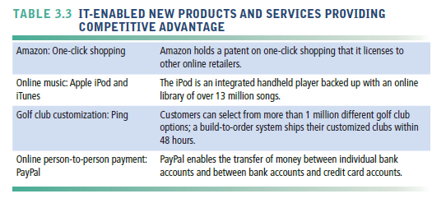

* Focus on Market Niche
* Use information systems to enable a specific market focus, and serve this narrow target market better than competitors.
* Information systems support this strategy by producing and analyzing data for finely tuned sales and marketing techniques.
* Information systems enable companies to analyze customer buying patterns, tastes, and preferences closely so that they efficiently pitch advertising and marketing campaigns to smaller and smaller target markets
* Sophisticated software tools find patterns in these large pools of data and infer rules from them to guide decision making.
* Analysis of such data drives one-to-one marketing that creates personal messages based on individualized preferences
* Example
* Hilton Hotels’ OnQ system analyzes detailed data collected on active guests in all of its properties to determine the preferences of each guest and each guest’s profitability
* customer relationship management (CRM) systems feature analytical capabilities for this type of intensive data analysis
* Strengthen Customer and Supplier Intimacy
* Use information systems to tighten linkages with suppliers and develop intimacy with customers.
* Example
* On the customer side, Amazon keeps track of user preferences for book and CD purchases, and can recommend titles purchased by others to its customers.
* Strong linkages to customers and suppliers increase switching costs (the cost of switching from one product to a competing product), and loyalty to your firm

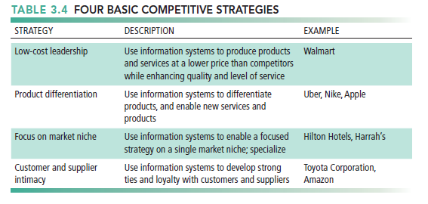

* + The Internet’s Impact on Competitive Advantage
* Universal standards allow new rivals, entrants to market
* the Internet has also created entirely new markets, formed the basis for thousands of new products, services, and business models, and provided new opportunities for building brands with very large and loyal customer bases.
* The Internet has nearly destroyed some industries and has severely threatened more
* the Internet is “transforming” entire industries, forcing firms to change how they do business.
* Examples: travel agency, printed encyclopedia, media
* For most forms of media, the Internet has posed a threat to business models and profitability.
* Smart Products and the Internet of Things
* Internet of Things (IoT)
  + - * an excellent example of how the Internet is changing competition within industries and creating new products and services.
* Smart products
  + - * offer new functionality, greater reliability, and more intense use of products
      * expand opportunities for product and service differentiation
      * raise switching costs and inhibit new entrants to a market
  + The Business Value Chain Model
* The value chain model highlights specific activities in the business where competitive strategies can best be applied and where information systems are most likely to have a strategic impact.
* This model identifies specific, critical leverage points where a firm can use information technology most effectively to enhance its competitive position.

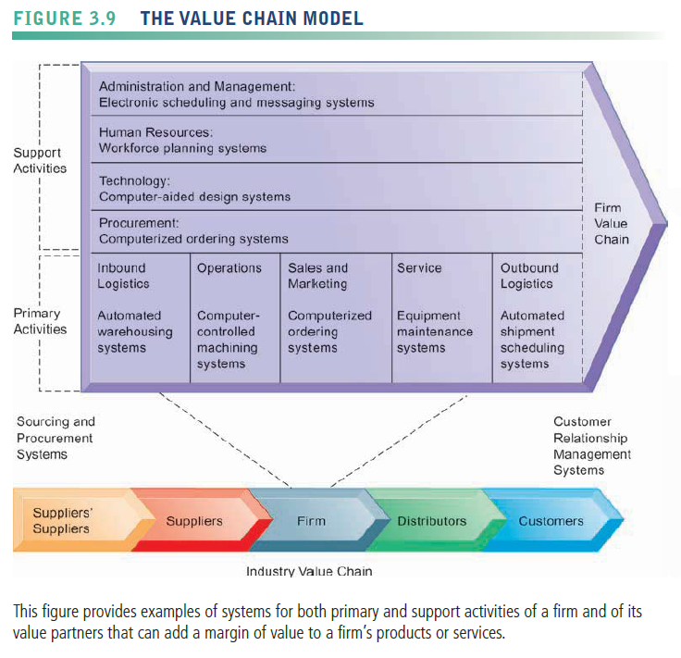

* Primary activities
* most directly related to the production and distribution of the firm’s products and services, which create value for the customer.
* include inbound logistics, operations, outbound logistics, sales and marketing, and service
* Inbound logistics(進貨物流) : receiving and storing materials for distribution to production.
* Operation : transforms inputs into finished products
* Outbound logistics(出貨物流) : storing and distributing finished products.
* Sales and marketing : promoting and selling the firm’s products
* service activity : maintenance and repair of the firm’s goods and services.
* Support activities
* make the delivery of the primary activities possible and consist of organization infrastructure (administration and management),human resources (employee recruiting, hiring, and training), technology (improving products and the production process), and procurement (purchasing input).
* Utilize benchmarking, industry best practices
* Benchmarking
  + - * involves comparing the efficiency and effectiveness of your business processes against strict standards and then measuring performance against those standards.
* best practices
  + - * usually identified by consulting companies, research organizations, government agencies, and industry associations as the most successful solutions or problem-solving methods for consistently and effectively achieving
* a business objective.
* Extending the Value Chain: The Value Web
* By working with other firms, industry participants can use information technology to develop industry-wide standards for exchanging information or business transactions electronically, which force all market participants to subscribe to similar standards.
* increase efficiency, making product substitution less likely and perhaps raising entry costs—thus discouraging new entrants
* Strategic advantage derives from your ability to relate your value chain to the value chains of other partners in the process.
* Internet technology has made it possible to create highly synchronized industry value chains called value webs
* a collection of independent firms that use information technology to coordinate their value chains to produce a product or service for a market collectively.
* flexible and adaptive to changes in supply and demand.

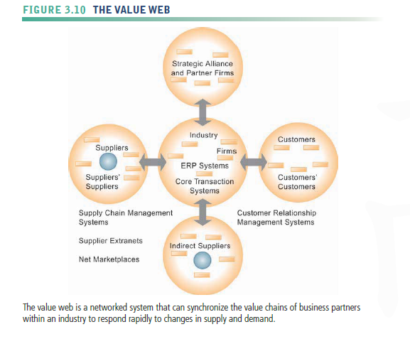

* + Synergies, Core Competencies, and Network-Based Strategies
* Preface
* Information systems can improve overall performance of business units by promoting synergies and core competencies
* Synergies(協同作用)
* when the output of some units can be used as inputs to other units, or two organizations pool markets and expertise, these relationships lower costs and generate profits.
* One use of information technology in these synergy situations is to tie together the operations of disparate business units so that they can act as a whole.
* Example
  + - * merger of Bank of NY and JPMorgan Chase
      * Purchase of YouTube by Google
* Enhancing Core Competencies
* use information systems for competitive advantage is to think about ways that systems can enhance core competencies.
* The argument is that the performance of all business units will increase insofar as these business units develop, or create, a central core of competencies.
* activity for which a firm is a world-class leader.
* relies on knowledge that is gained over many years of practical field experience with a technology.
* Any information system that encourages the sharing of knowledge across business units enhances competency
* encourage or enhance existing competencies and help employees become aware of new external knowledge
* help a business leverage existing competencies to related markets
* Example
* Procter & Gamble’s intranet and directory of subject matter experts
* Network-Based Strategies
* Take advantage of firm’s abilities to network with one another

1. Network economics
2. Virtual company model
3. Business ecosystems

* Traditional economics: Law of diminishing returns
* The more any given resource is applied to production, the lower the marginal gain in output, until a point is reached where the additional inputs produce no additional outputs
* Network Economics
* Business models based on a network may help firms strategically by taking advantage of network economics.
* the marginal costs of adding another participant are about zero, whereas the marginal gain is much larger.
* The value of a community of people grows with size, whereas the cost of adding new members is inconsequential.
* The value of their software and complementary software products increases as more people use them, and there is a larger installed base to justify continued use of the product and vendor support.
* Virtual Company Model
* Virtual company uses networks to ally with other companies to create and distribute products without being limited by traditional organizational boundaries or physical locations
* Example: Li & Fung manages production, shipment of garments for major fashion companies, outsourcing all work to more than 7,500 suppliers
* Business Ecosystems: Keystone and Niche Firms
* Industry sets of firms providing related services and products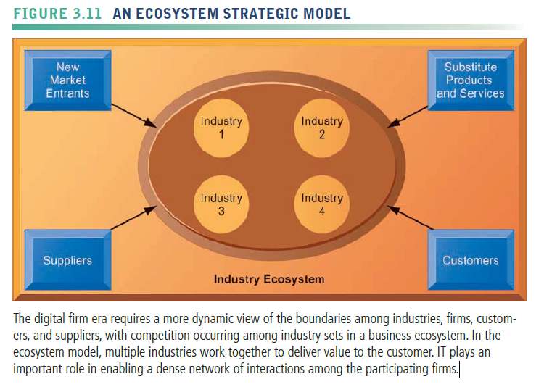
* **Business ecosystem** is another term for these loosely coupled but interdependent networks of suppliers, distributors, outsourcing firms, transportation service firms, and technology manufacturers
* The concept of a business ecosystem builds on the idea of the value web described earlier, the main difference being that cooperation takes place across many industries rather than many firms.
* Business ecosystems can be characterized as having one or a few keystone firms that dominate the ecosystem and create the platforms used by other niche firms.
* Keystone firms: Dominate ecosystem and create platform used by other firms
* Niche firms: Rely on platform developed by keystone firm
* expect greater emphasis on the use of IT to build industry ecosystems because the costs of participating in such ecosystems will fall and the benefits to all firms will increase rapidly as the platform grows.
* Individual firms should consider how their information systems will enable them to become profitable niche players in larger ecosystems created by keystone firms.
* A powerful, current example of a rapidly expanding ecosystem is the mobile Internet platform

1. USING SYSTEMS FOR COMPETITIVE ADVANTAGE: MANAGEMENT ISSUES
   * Sustaining Competitive Advantage

* The competitive advantages that strategic systems confer do not necessarily last long enough to ensure long-term profitability.
* Information systems alone cannot provide an enduring business advantage.
* Systems originally intended to be strategic frequently become tools for survival, required by every firm to stay in business, or they may inhibit organizations from making the strategic changes essential for future success.
  + Aligning IT with Business Objectives
* The research on IT and business performance has found that the more successfully a firm can align information technology with its business goals, the more profitable it will be.
* Successful firms and managers understand what IT can do and how it works, take an active role in shaping its use, and measure its impact on revenues and profits.
* Management Checklist: Performing a Strategic Systems Analysis
* Structure of industry
* Firm value chains
  + Managing Strategic Transitions
* These sociotechnical changes, affecting both social and technical elements of the organization, can be considered strategic transitions— a movement between levels of sociotechnical systems.
* Managers will need to devise new business processes for coordinating their firms’ activities with those of customers, suppliers, and other organizations.
* Adopting strategic systems requires changes in business goals, relationships with customers and suppliers, and business processes